# Transfer OSM file into MATSim multimodal network file

1. Go to Openstreetmap website: <https://www.openstreetmap.org>

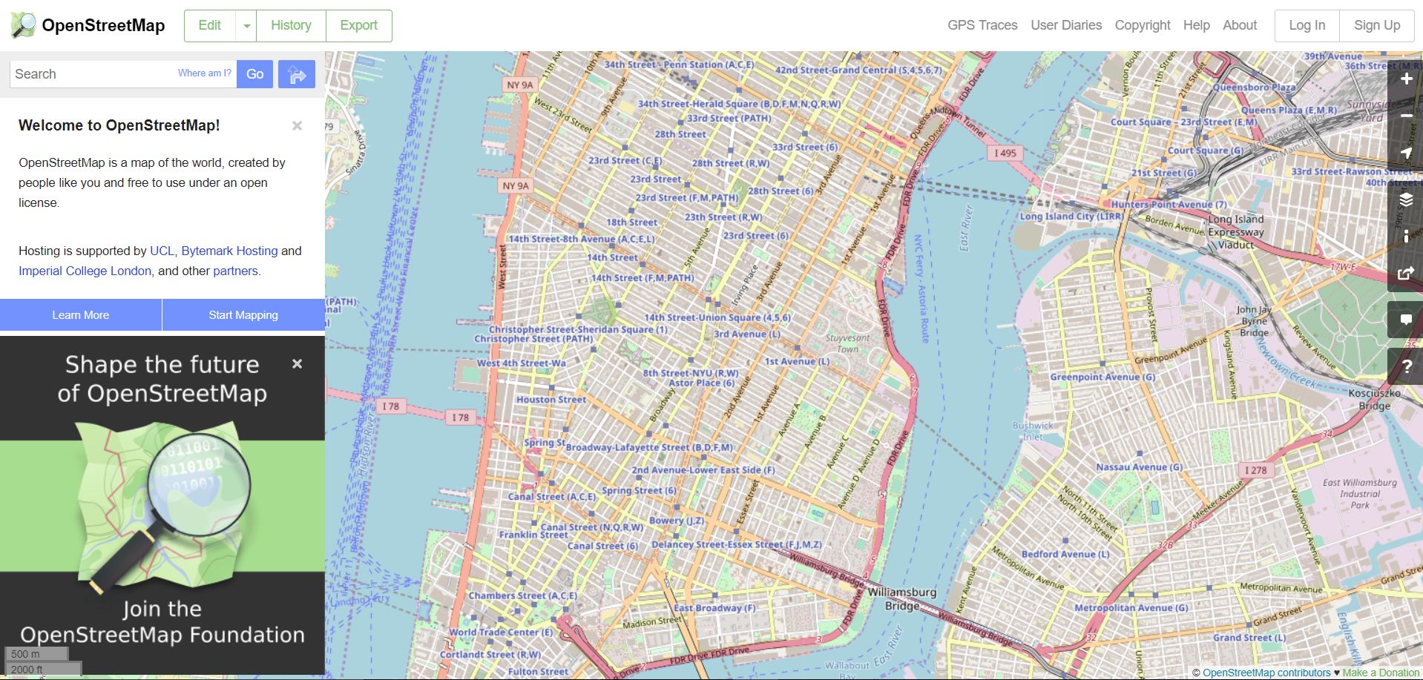

1. Click Export button on the top:

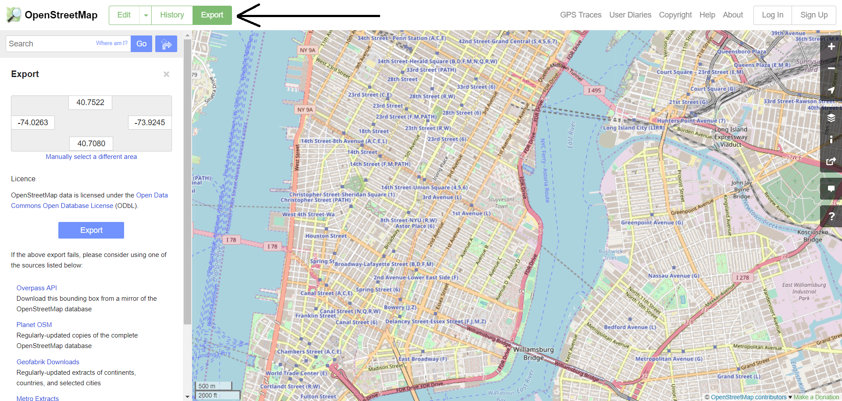

1. If you want to export a small area, you could enter the boundary of your area (longitude and latitude) or click “Manually select a different area” to select a rectangular area. For large area, you could select “Planet OSM”and then “BBBike.org”

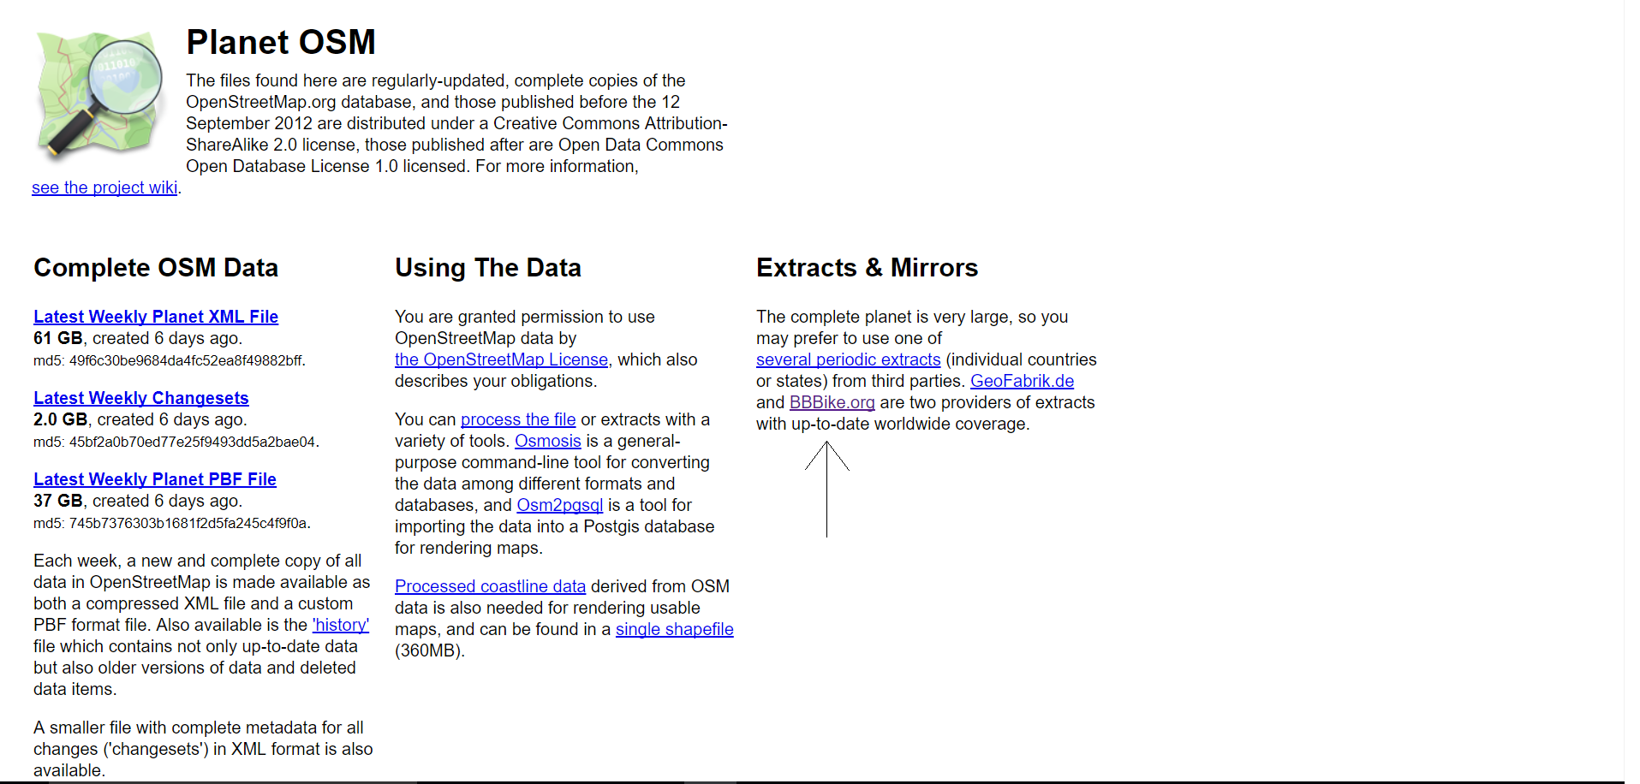

1. Click “Select your own region” to select a specific area. Click extract and you will get a compressed osm file.

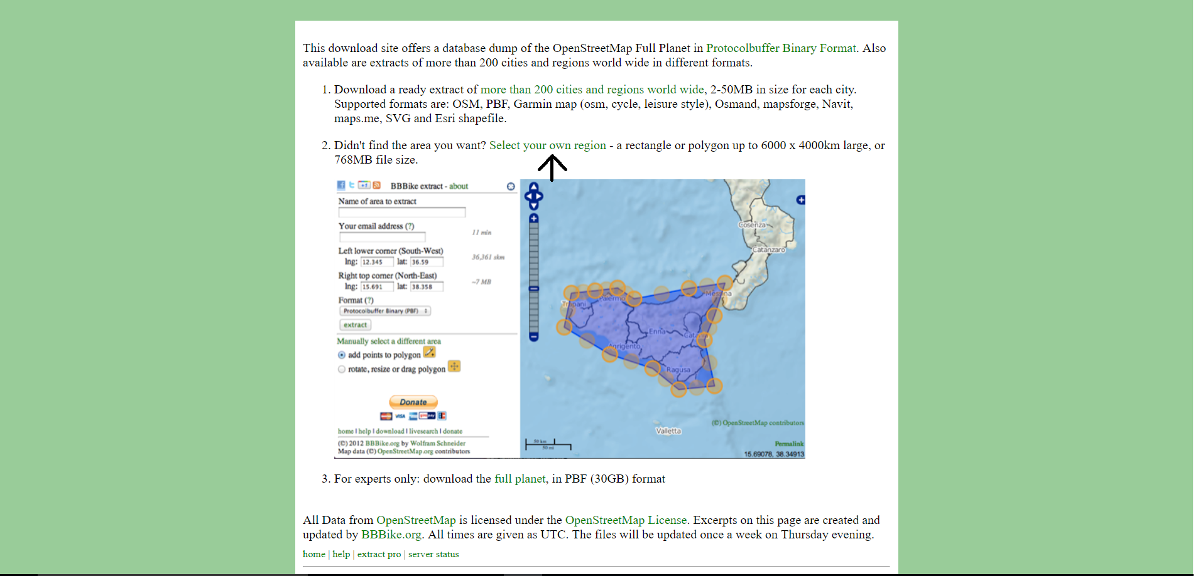

1. Uncompress the osm file. Edit the network config file. Change the parameters below into your own value.

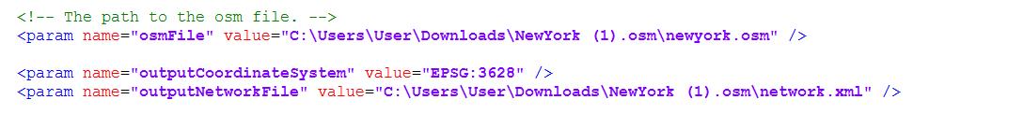

1. Run the Osm2MultimodalNetwork.java, the argument is the path of network config file. A MATSim multimodal network file will be generated in the location you set in the config file.